Step‐By‐Step Guide how to Prep and Chalk Fields

***Raking/ Dragging***– Rake/ Drag the area around the plates and smooth out any lump’s rocks, or holes. You should do this along the base paths as well. (Water field first if you think is required) Maintenance guys from Pima County Parks drag all fields every (**Monday-Wednesday-Friday**) please contact Supervisor 8hrs before your home game to make sure field is dragged **all depends on their availability (Travis @ 520-724-5183)

* 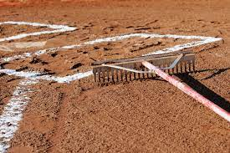A person in a blue shirt on a baseball field

  Description automatically generated*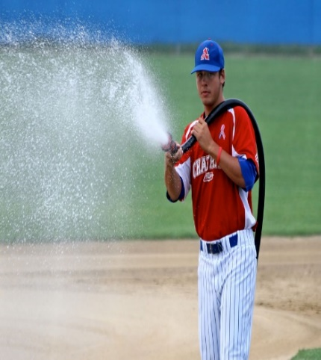****Water Field***– Water field using special adapter that connects right behind pitchers’ mound, gentle spray water side to side starting home plate following around infield, this will help prevent high dust during raking.

*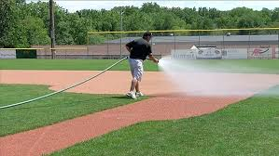****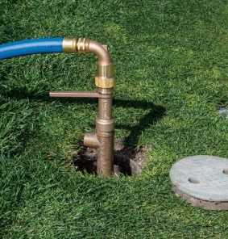***

* ***Set Your String*** – Hammer stake attached to string reel to the back edge of home plate run string through “yellow ground marker” by 1st base through second “yellow marker” by grass line. Always make sure the string is straight.

*Follow same steps for 3rd base line.*

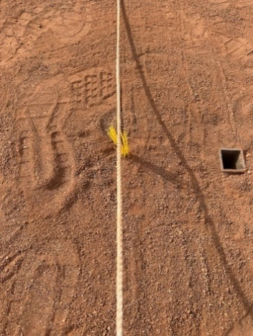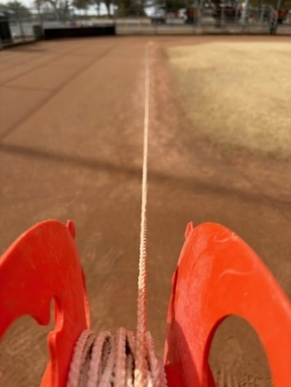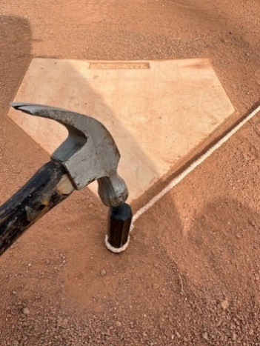

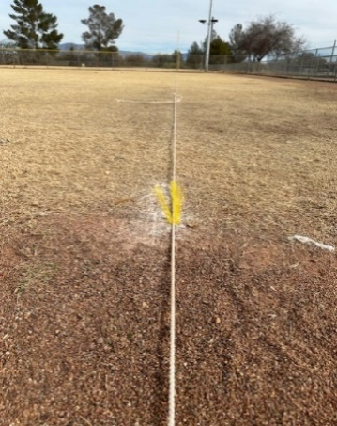

* **Base steel anchors**– Sometimes is hard to find base anchors due to “dirt plug” missing or stolen, you can find base female anchor approx. 5-9” inboard (measured from “yellow ground marker”) use dig out tool to remove dirt.

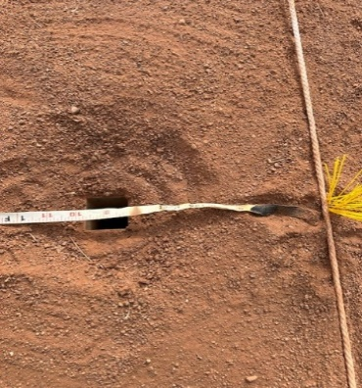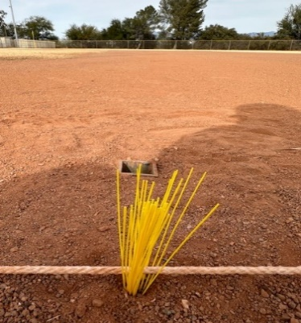

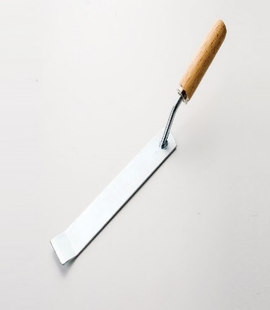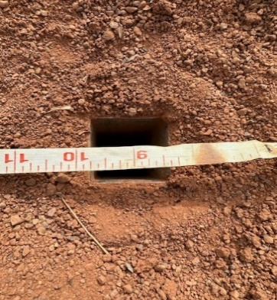

* ***Chalk lines –*** Slow open chalk cart lever to 2” wide (inside of white string) start from outer batter box corner line all the way to outfield, stop till you get into 2nd yellow marker area.

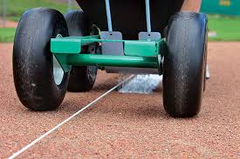

* ***Chalk Batter’s Box –*** For the batter’s box connect yellow Trail Chasers “ground markers” with chalk cart (Field#1 Youth Baseball – 3’ x 6’ Field #3 Adult Baseball – 4’ x 6’ Field #2 Softball – 3’ x 7’)

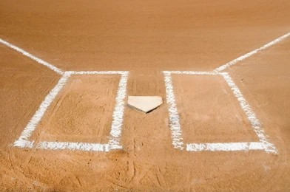

* ***1st and 3rd coaches Box –*** For coach box connect yellow trail “ground marker” with chalk cart.

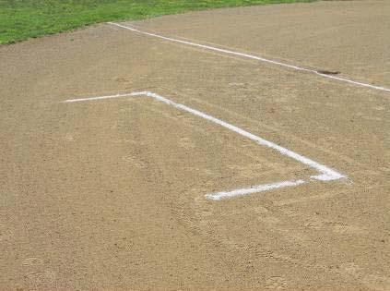

* ***Install Bases –*** Remove Rubber plug and install bases into female anchor.

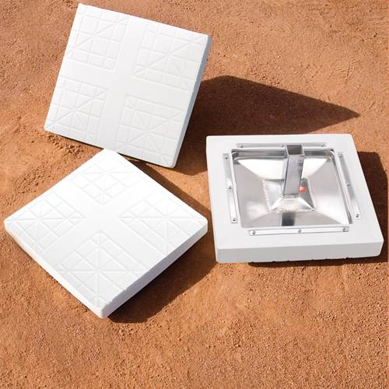

* ***After each game –*** Place bases in Black equipment box, install rubber plug into field base anchors.

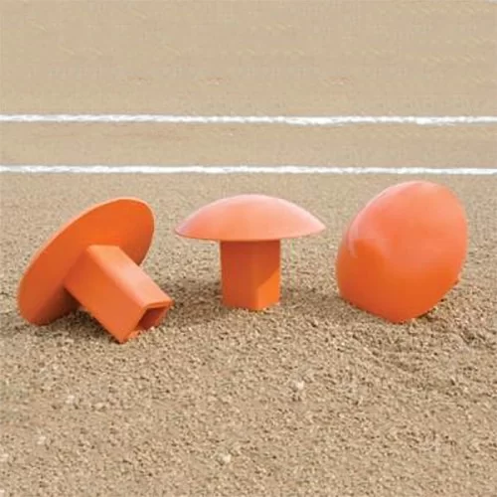

**REMINDER: (Before you leave home field)**

1. **Make sure equipment box lid is closed and locks are pushed in.**

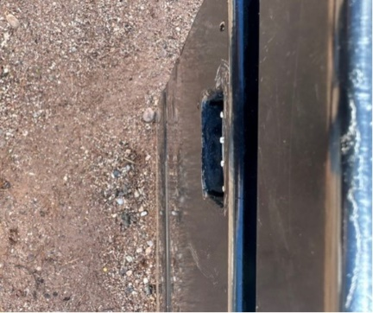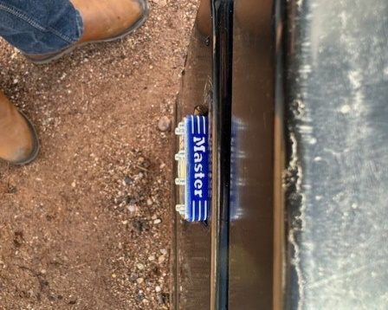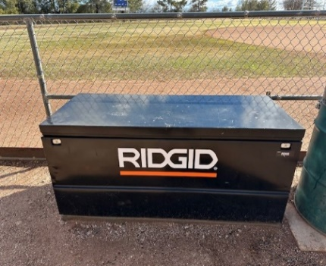

**2.Double check batting cage chain lock is closed.**

**Items that should be in equipment box:**

**Please notify LNLL Equipment Manager/ Rudy Munoz (602-781-1409) and League President (520-338-4266) when equipment is missing or misplaced.**

